**PRACTICAL FILE**

**NAME** – NITISH KUMAR

**COURSE -** BCA (AIML)

**GROUP** – 1B

**Q1**. Create a simple html page using basic tags.

Output -<html>

<head>

<title> Student Information </title>

</head>

<body>

<h4> Basic Tags</h4>

</body>

</html>

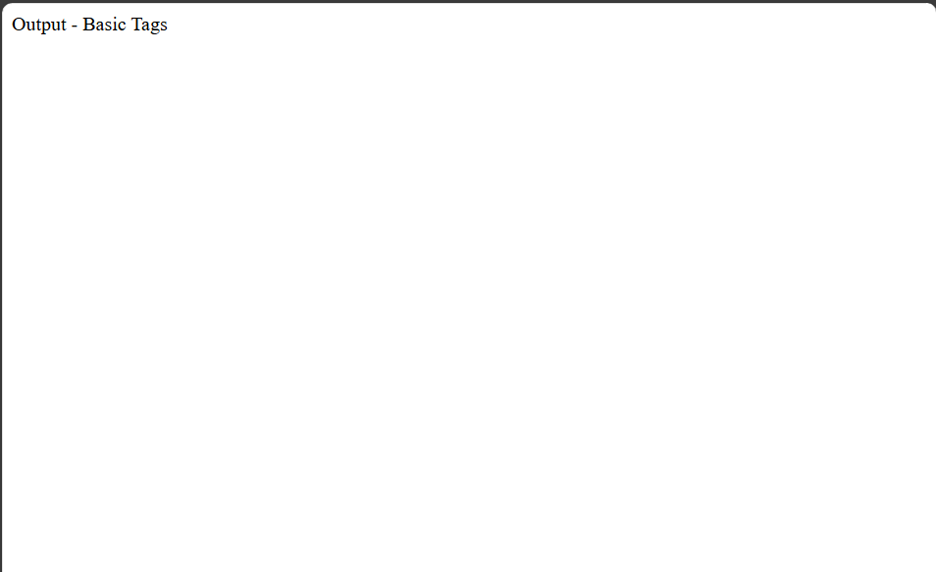

**Q2.** Create a web page that displays your name to the screen.

Input -

html>

<head>

<title> Student Information </title>

</head>

<body <style="background-color:powderblue;">

<h4 style="background-color:violet;"> Student Name - NITISH KUMAR </h4>

</body>

</html>

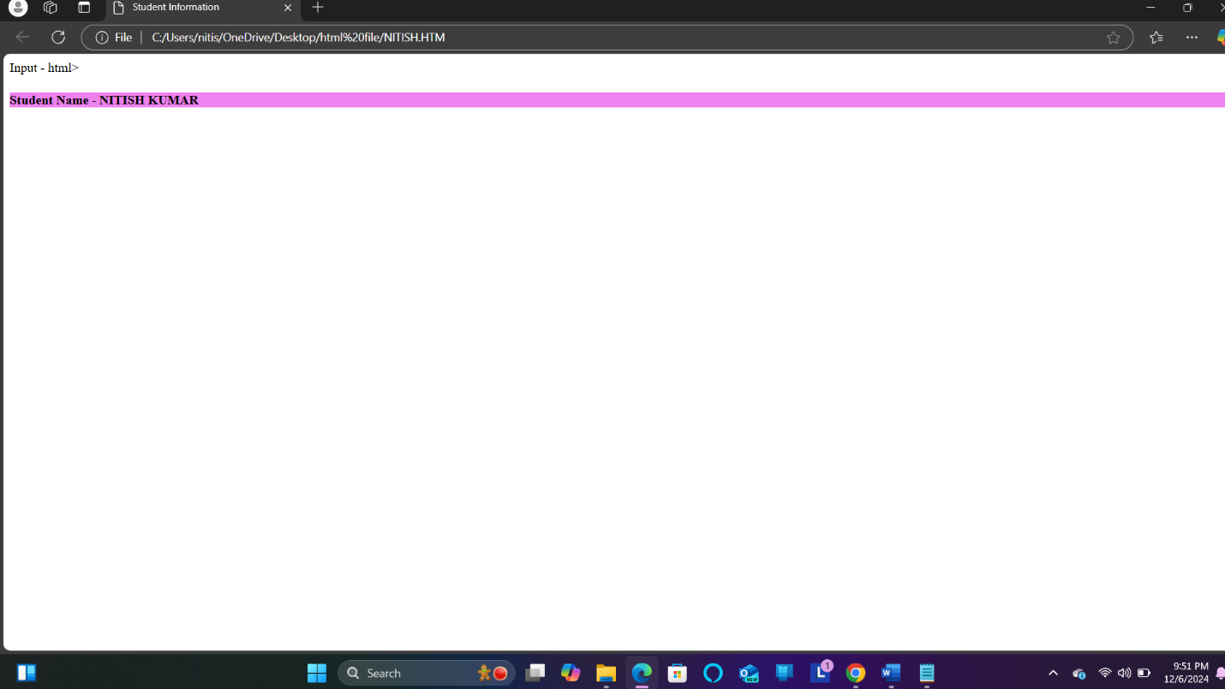

**Q3.** Create a web page and show the output from 1 to 10 in separate lines.

<html>

<head>

<title> Student Information </title>

</head>

<body style="background-color:powderblue;">

<h4 style="background-color:violet;"> Student Name - Nitish kumar </h4>

<p style="color:blue;"> 1 </p>

<p style="color:purple;"> 2 </p>

<p style="color:orange;"> 3 </p>

<p style="color:pink;"> 4 </p>

<p style="color:green;"> 5 </p>

<p style="color:red;"> 6 </p>

<p style="color:brown;"> 7 </p>

<p style="color:black;"> 8 </p>

<p style="color:violet;"> 9 </p>

<p style="color:yellow;"> 10 </p>

</body>

</html>

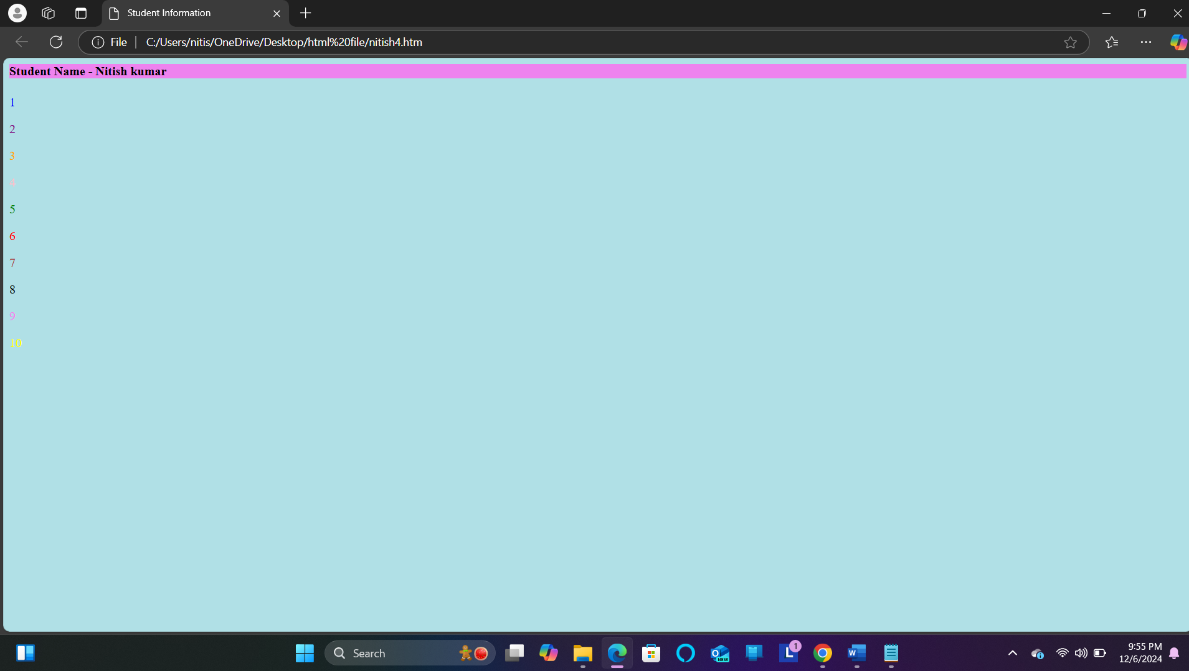

**Q5. How do I make a picture as a background on my web pages?**

**<html>**

**<head>**

**<title> Student Information </title>**

**</head>**

**<body style="background-color:powderblack;">**

**<h3 style="color:violet;"> Adding picture to background </h3>**

**<img src="https://encrypted-tbn0.gstatic.com/images?q=tbn:ANd9GcQEc9A_S6BPxCDRp5WjMFEfXrpCu1ya2OO-Lw&s">**

**</body>**

**</html>**

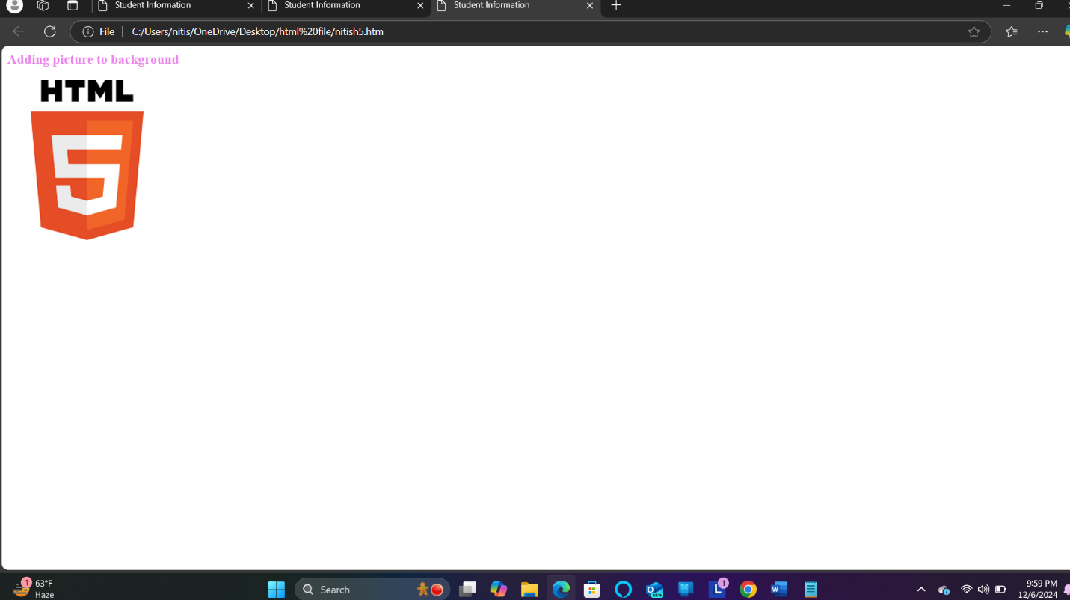

**Q6**. Create a web page to print paragraph with 4-5 snetences, each sentence shall have a different colour.

<html>

<head>

<title> Student Information </title>

</head>

<body style="background-color:powderblue;">

<h5 style="Font-Family:Cursive;"> This is Paragraph one </h3>

<h4 style="Font-Family:Fantasy;"> This is Paragraph two </h2>

<h3 style="Font-Family:Helvetica;"> This is Paragraph three </h5>

<h2 style="Font-Family:Courier New;"> This is Paragraph four </h4>

<h1 style="Font-Family:Verdana New;"> This is Paragraph five</h1>

</body>

</html>

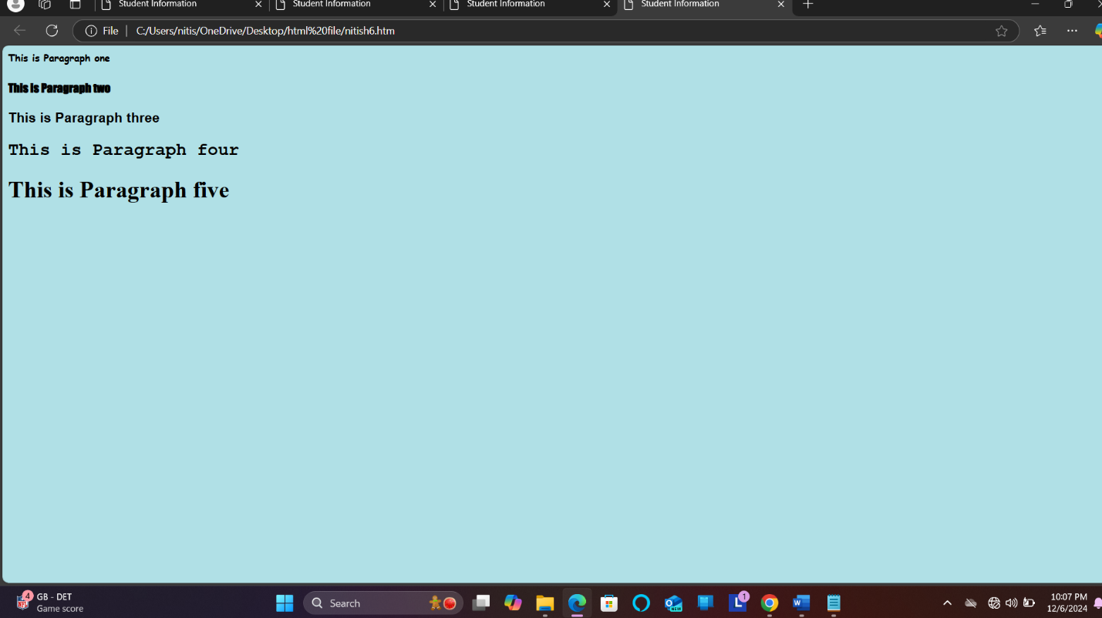

**Q7.** Write HTML code to print a paragraph that is descriptions of a book, it shall include the title of book, its author name; name and title should be underlined and all adjactives shall be bold and italics.

**Ans. <HTML>**

**<HEAD>**

**<TITLE>INTRODUCTION</TITLE>**

**</HEAD>**

**<BODY bgcolor="dark orange">**

**<h1 style="color:gold;"><u><b><center> LORD OF THE RINGS </center></b></u></h1>**

**<h2 style="color:gold;"><u><b><center> J.R.R. TOLKIEN </center></b></u></h2>**

**<h3><b>GENRE</b></h3>**

**<b><i>Epic</i></b> highly <b><i>fantasy</i></b> novel.**

**<h3><b>READ IF</b></h3>**

**You love <b><i>fantasy</i></b> world and have a <b><i>passion</i></b> for heavy writing, deep explanations.**

**<h3><b>FUN FACT </b></h3>**

**Tolkien is said to have typed all 1200 pages of The Lord of rings with two fingers.**

**<br>**

**<p>**

**The Lord of rings is highly <i><b>fantasy</i></b> novel, written between 1937-1949. All three parts of the masterpiece are steeped in magic and otherworldliness. The epic story centres around <b>Frodo Baggins</b>, who is force to leave his hometown of the Shire to make a<b><i> perilous</i></b> journey across the realm of Middl-earth to destroy a powerful ring, deep inside the territories of the Dark Lord Sauron.**

**</p>**

**</BODY>**

**</HTML>**

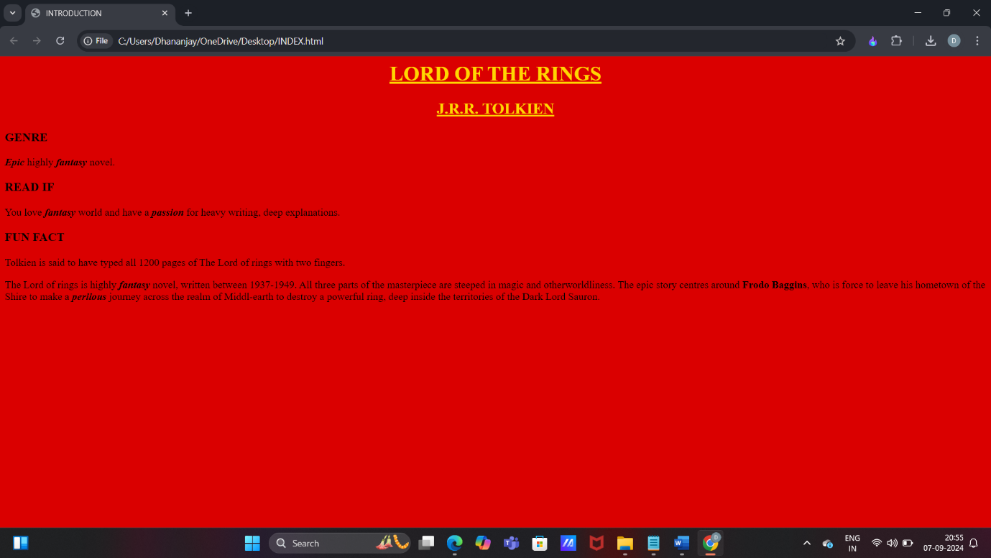

**Q8.**  Write HTML code to print your name using heading tags, every letter shall be of different heading size.

<html>

head>

<title> Heading Tag </title>

</head>

<body style="background-color:powderblue;">

<h1>N</h1>

<h2>I</h2>

<h3>T</h3>

<h4>I</h4>

<h5>S</h5>

<h1>H</h1>

</body>

/html>

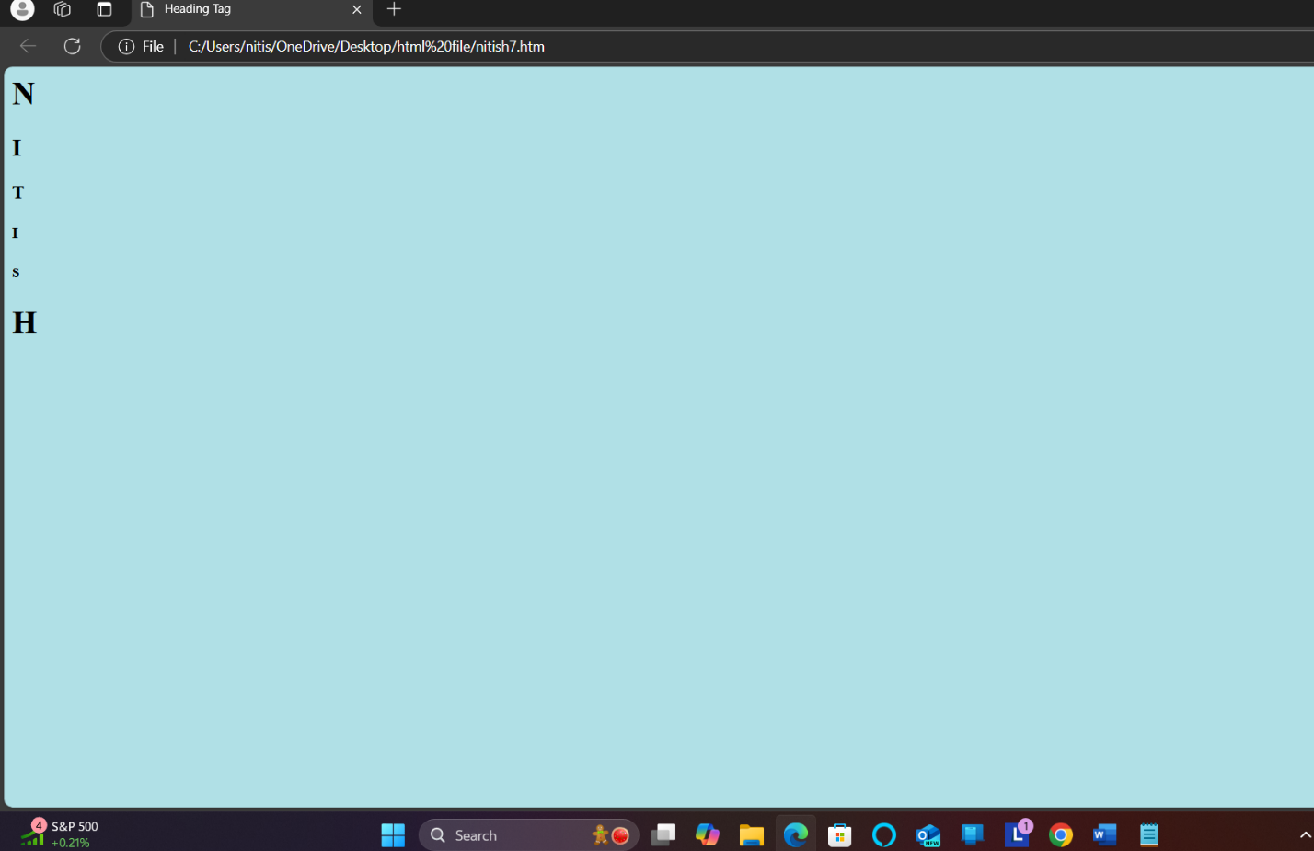

**Q9.** Write HTML code to print the sequence of number 1-20. Each number shall be in different line with number 2 next to it as subscript, an equal sign and result.

**ANS.** **<HTML>**

**<HEAD>**

**<TITLE>INTRODUCTION</TITLE>**

**</HEAD>**

**<BODY>**

**<p>1<sub>2</sub> = 1</p>**

**<p>2<sub>2</sub> = 4</p>**

**<p>3<sub>2</sub> = 9</p>**

**<p>4<sub>2</sub> = 16</p>**

**<p>5<sub>2</sub> = 25</p>**

**<p>6<sub>2</sub> = 36</p>**

**<p>7<sub>2</sub> = 49</p>**

**<p>8<sub>2</sub> = 64</p>**

**<p>9<sub>2</sub> = 81</p>**

**<p>10<sub>2</sub> = 100</p>**

**<p>11<sub>2</sub> = 121</p>**

**<p>12<sub>2</sub> = 144</p>**

**<p>13<sub>2</sub> = 169</p>**

**<p>14<sub>2</sub> = 196</p>**

**<p>15<sub>2</sub> = 224</p>**

**<p>16<sub>2</sub> = 256</p>**

**<p>17<sub>2</sub> = 289</p>**

**<p>18<sub>2</sub> =324 </p>**

**<p>19<sub>2</sub> = 361</p>**

**<p>20<sub>2</sub> = 400</p>**

**</BODY>**

**</HTML>**

**OUTPUT –**

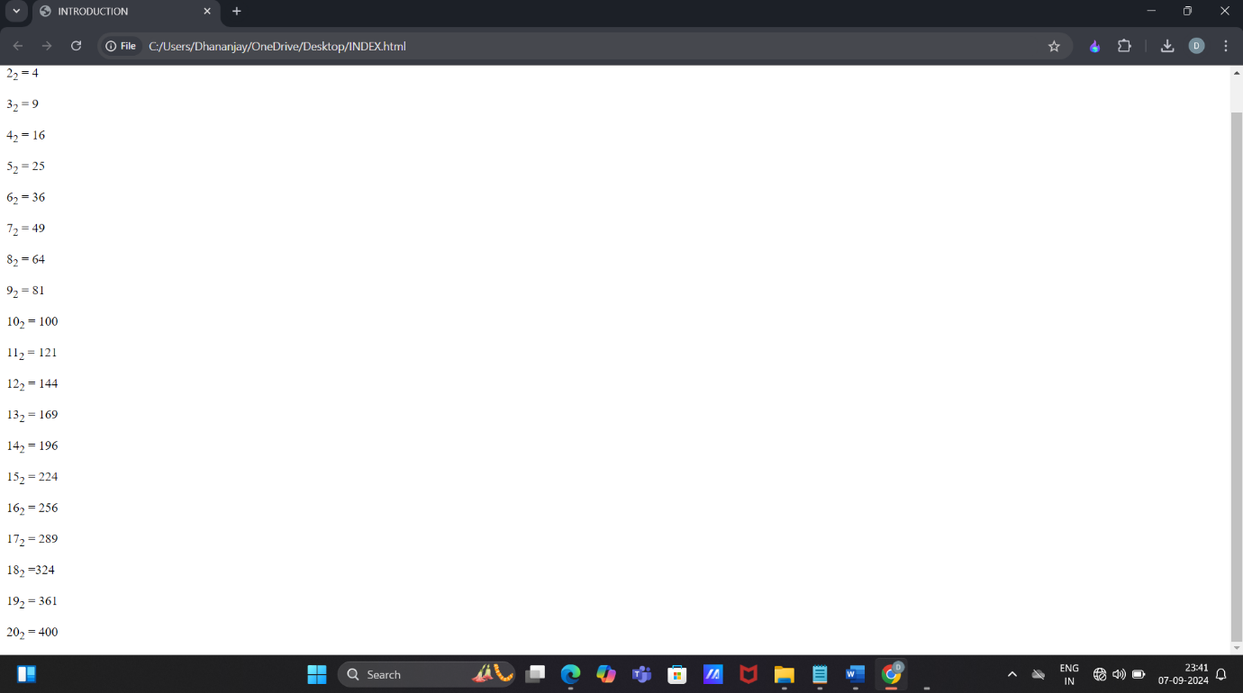

**Q10. Write HTML code to display an image with border of size with width 200, height 200 pixel, leaving H space and V space of your choice with image hanging in the right side on the screen.**

**Ans. <HTML>**

**<HEAD>**

**<TITLE>INTRODUCTION</TITLE>**

**<style>**

**img{**

**border:2px solid black;**

**width:200px;**

**height:200px;**

**display:block;**

**margin-left:auto;**

**margin-right:0;**

**margin-top:50px;**

**margin-bottom:40px;**

**</style>**

**</HEAD>**

**<BODY>**

**<img src="C:\Users\NITISH\Pictures\Screenshots/display.jpg"**

**alt="sample image">**

**</BODY>**

**</HTML>**

**OUTPUT –**

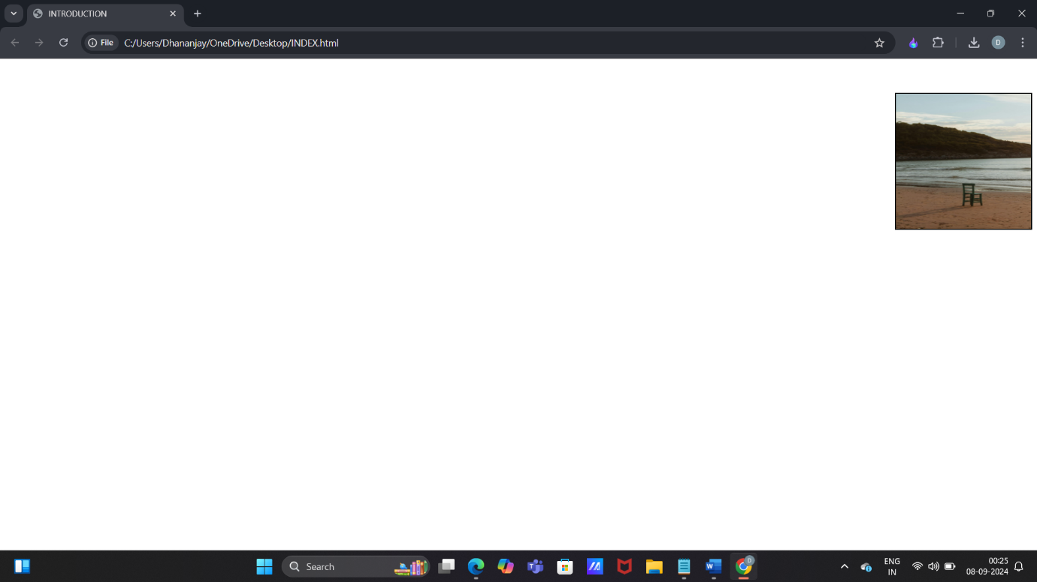

**Q11. Write HTML code to create a web page with heading. The heading shall be displayed at the top-center of the page and the image shall be at the center, just below the heading.**

**Ans. <HTML>**

**<HEAD>**

**<TITLE>INTRODUCTION</TITLE>**

**<style>**

**body{**

**margin:0;**

**font-family:arial, sans-serif;**

**text-align:center;**

**justify-content:center;**

**align-items:center;**

**</style>**

**</head>**

**<body>**

**<h1>GANESH CHATURTHI 2024</h1>**

**<img src="C:\Users\Dhananjay\OneDrive\Pictures/modak.jpg"**

**alt="FESTIVAL CELEBRATION">**

**</BODY>**

**</HTML>**

**OUTPUT –**

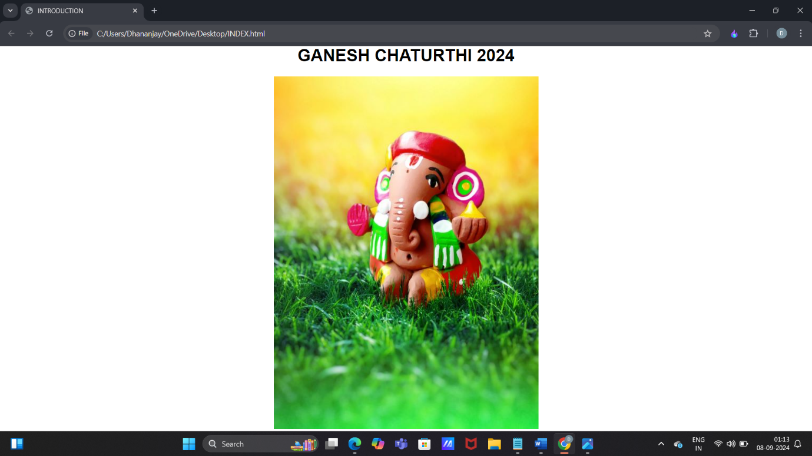

**Q12. Write HTML code using Multimedia tags.**

**Ans. <HTML>**

**<HEAD>**

**<TITLE>MULTIMEDIA TAGS</TITLE>**

**</head>**

**<body>**

**<h1 align="center">MULTIMEDIA</H1>**

**<hr>**

**<video src="C:\Users\nitish\OneDrive\Pictures/jungle.mp4" controls="controls" width="720" height="480">**

**</video>**

**<br>**

**<audio src="C:\Users\nitish\OneDrive\Pictures/nightforest.mp3" controls="controls" autoplay="autoplay">**

**<embed src="name.pdf" width="px" height="px">**

**<object data="file.name" width="px" height="px">**

**</object>**

**</BODY>**

**</HTML>**

**OUTPUT –**

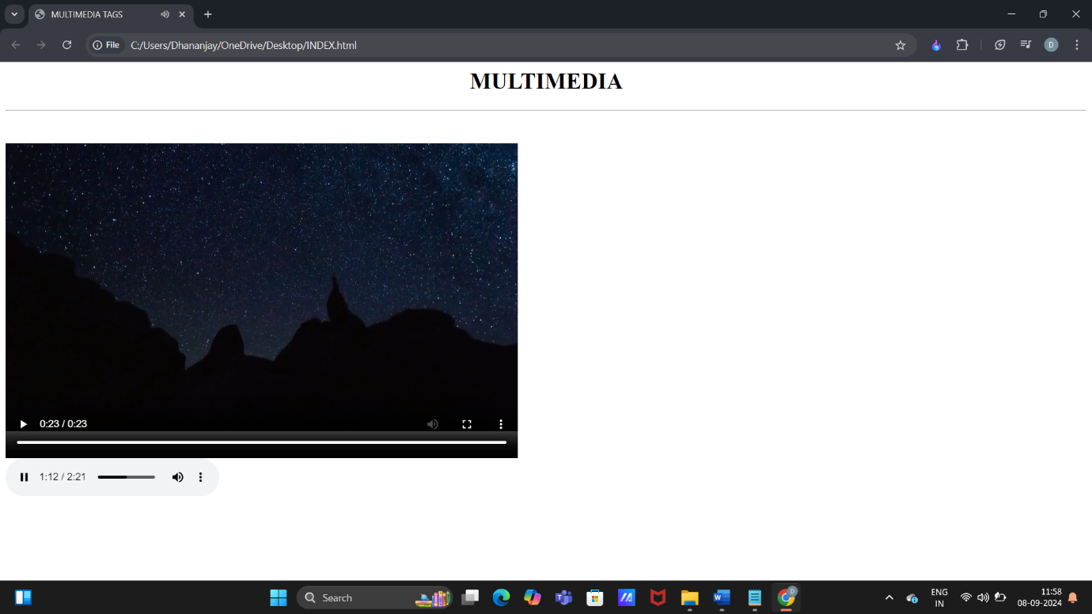

**Q13. Create a Table using Rowspan and Colspan taking example of student record.**

**Ans. <html>**

**<head>**

**<title>table</title>**

**</head>**

**<body>**

**<table border="2">**

**<tr>**

**<td rowspan="2">ATTENNDENCE</td>**

**<td>70%</td>**

**<td>80%</td>**

**<td></td>**

**<td></td>**

**</tr>**

**<tr>**

**<td>DETAIN</td>**

**<td>AVAIL</td>**

**<td></td>**

**<td></td>**

**</tr>**

**<tr>**

**<th colspan="2"> NAME </th>**

**<th>ROLL NO </th>**

**<th>COURSE</th>**

**<th>LOCATION</th>**

**</tr>**

**<tr>**

**<td>SHIVAM</td>**

**<td>SINGH</td>**

**<td>01</td>**

**<td>MCA</td>**

**<td>DELHI</td>**

**</tr>**

**<tr>**

**<td>MANU</td>**

**<td>PRATAP</td>**

**<td>02</td>**

**<td>BCA</td>**

**<td>RAJASTHAN</td>**

**</tr>**

**<tr>**

**<td rowsplan="2">ROHIT</td>**

**<td>GAUTAM</td>**

**<td>03</td>**

**<td>BBA</td>**

**<td>HARYANA</td>**

**</tr>**

**<tr>**

**<td>KAMLESH</td>**

**<td>PANDEY</td>**

**<td>04</td>**

**<td>B.COM</td>**

**<td>BIHAR</td>**

**</tr>**

**</table>**

**</body>**

**</html>**

**OUTPUT-**

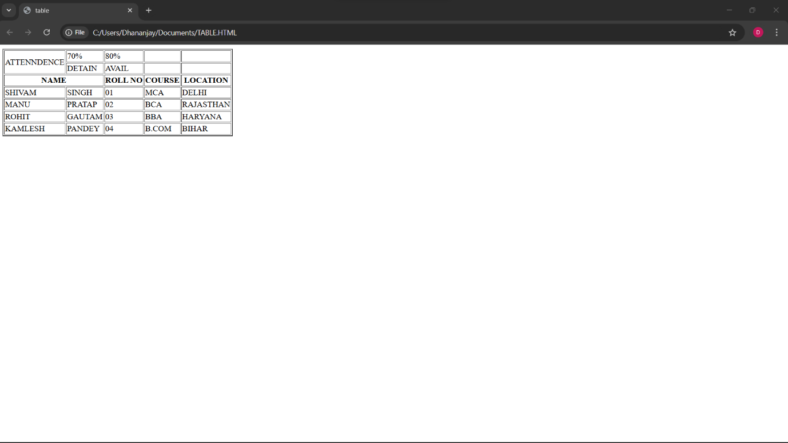

**Q14. Write HTML code using table tags <TABLE> and cellpadding and cell spacing as its attributes.**

**ANS.**

**<html>**

**<head></head>**

**<body>**

**<table border="2pt" cellspacing="5pt" cellpadding="5pt">**

**<tr>**

**<th>S.no</th>**

**<th>Roll no.</th>**

**<th>Name</th>**

**<th>Address</th></tr>**

**<tr>**

**<td>1</td>**

**<td>123</td>**

**<td>ABC</td>**

**<td>FBD</td></tr>**

**<tr>**

**<td>2</td>**

**<td>456</td>**

**<td>XYZ</td>**

**<td>delhi</td></tr>**

**<tr>**

**<td>3</td>**

**<td>789</td>**

**<td>PQR</td>**

**<td>gurgaon</td></tr>**

**</table></body>**

**</html>**

**OUTPUT –**

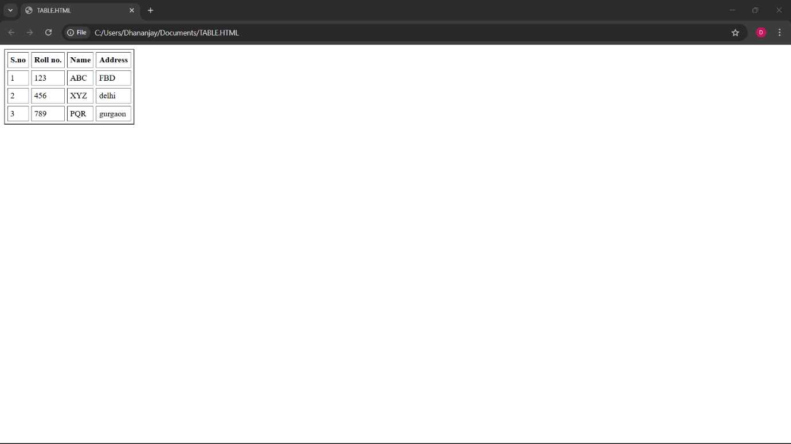

**Q15. Create unordered, ordered and definition lists taking example of your subjects in MCA, IST, Iind and IIIrd semester.**

**ANS.**

**html>**

**<head></head>**

**<body>**

**<h2> Subjects in BCA sem 1</h3>**

**<ol>**

**<li>Web technologies</li>**

**<li>Introduction to IT & programming in C</li>**

**<li>Mathematics</li>**

**<li>DBMS</li>**

**<li>SDGs</li>**

**<li>IKS</li>**

**<li>CDCs</li>**

**</ol>**

**<h2> Sunject in BCA sem 2 </h2>**

**<ul>**

**<li>COMMUNICATION</li>**

**<li>DATA STRUCTURE</li>**

**<li>JAVA</li>**

**<li>OPERATING SYSTEM</li>**

**<li>STATICS FOR BCA</li>**

**</ul>**

**<h2>Subjects in BCA Sem 3</h2>**

**<dl>**

**<dt>C++</dt>**

**<dt>COMPUTER ARCHITECTURE</dt>**

**<dt>BUSINESS ECONOMICS</dt>**

**<dt>ELEMENT OF STATICS</dt>**

**<dt>DSA OF C++</dt>**

**</dl>**

**</body>**

**</html>**

**OUTPUT –**

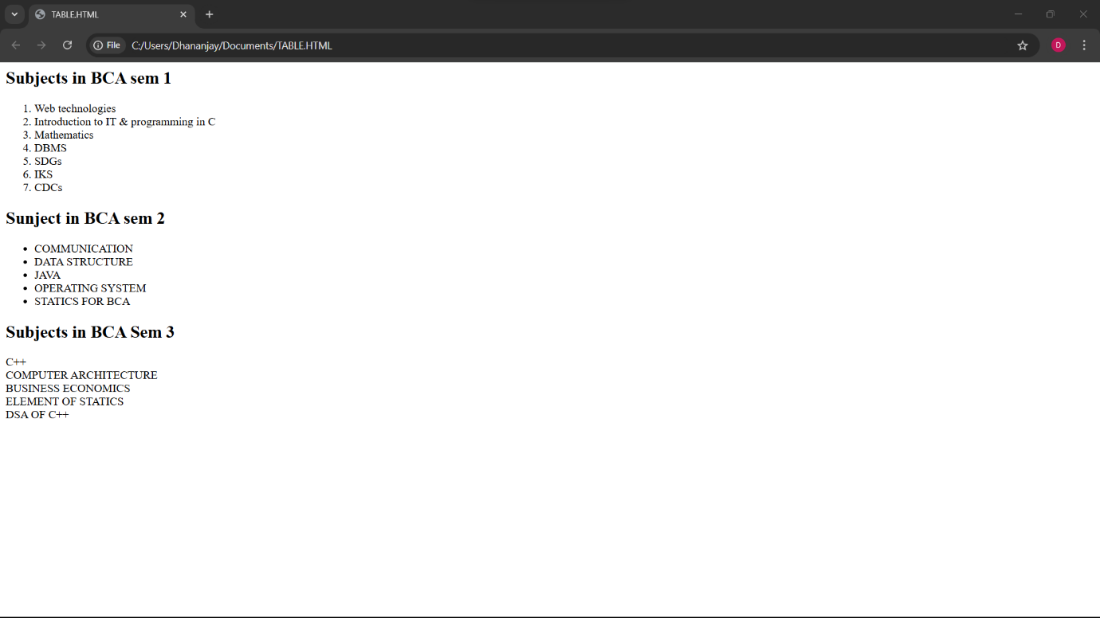

**Q16. Write HTML code using <frameset> and <frame> tag with all its attributes.**

**ANS. <html>**

**<head>**

**<title>Frameset Example</title>**

**</head>**

**<frameset rows="50%,50%" frameborder="1" bordercolor="black" framespacing="5">**

**<frame src="https://www.example.com" name="topFrame" scrolling="yes" noresize="noresize" target="_self" />**

**<frame src="https://www.example.org" name="bottomFrame" scrolling="auto" noresize="noresize" target="_self" />**

**</frameset>**

**<noframes>**

**<body>**

**<p>Your browser does not support frames. Please update your browser.</p>**

**</body>**

**</noframes>**

**</html>**

**OUTPUT-**

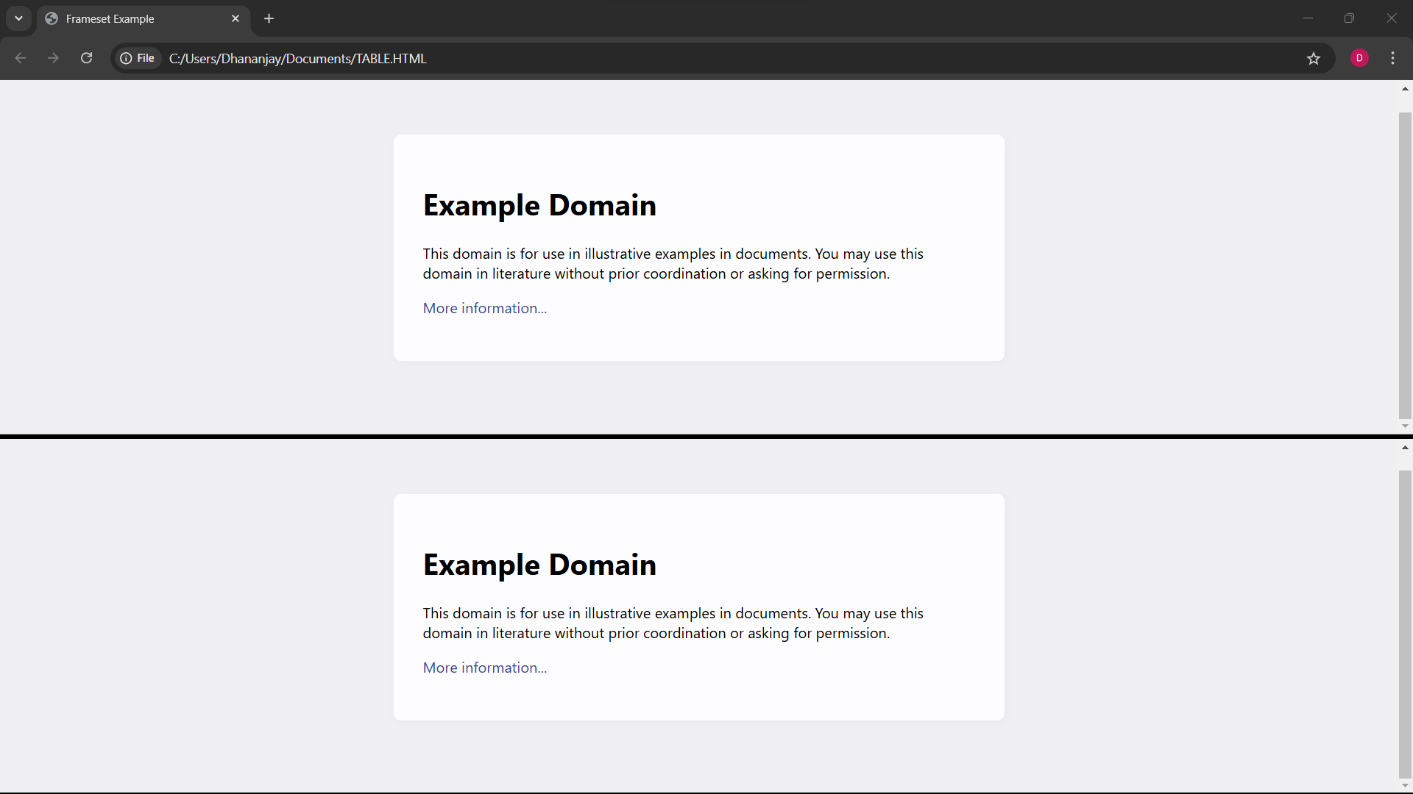

**Q17. Write HTML code to design a form in HTML using controls and buttons such as Textbox, Text area,**

**password, submit button, browse button, drop-down menu.**

**ANS.**

**<html>**

**<head>**

**<title>Form with Various Controls</title>**

**</head>**

**<body>**

**<h1>Registration Form</h1>**

**<form action="submit.php" method="post" enctype="multipart/form-data">**

**<label for="name">Name:</label>**

**<input type="text" id="name" name="name" required><br><br>**

**<label for="email">Email:</label>**

**<input type="email" id="email" name="email" required><br><br>**

**<label for="password">Password:</label>**

**<input type="password" id="password" name="password" required><br><br>**

**<label for="profile_pic">Photograph:</label>**

**<input type="file" id="profile_pic" name="profile_pic"><br><br>**

**<label for="country">Country:</label>**

**<select id="country" name="country">**

**<option value="india">India</option>**

**<option value="usa">USA</option>**

**<option**

**value="uk">UK</option>**

**</select><br><br>**

**<label for="message">Message:</label>**

**<textarea id="message" name="message" rows="5" cols="30"></textarea><br><br>**

**<input type="submit" value="Submit">**

**<input type="reset" value="Reset"><br><br>**

**</form>**

**</body>**

**</html>**

**OUTPUT –**

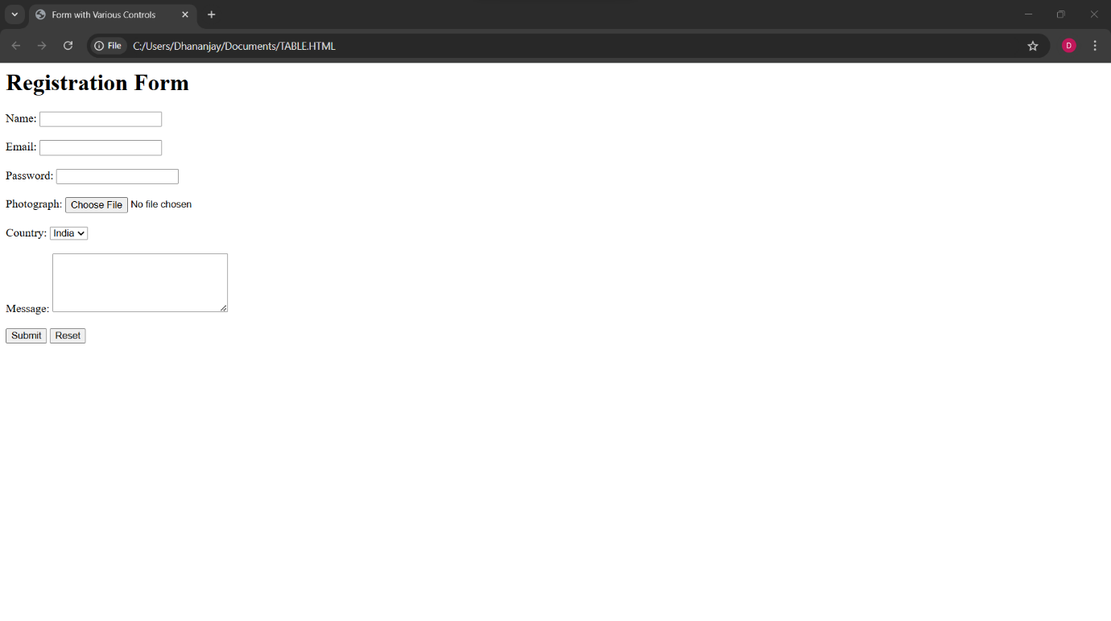

**Q18. Write HTML code to design a registration form in html.**

**ANS.**

**<html>**

**<head>**

**<tiTLE> Registration Form</title>**

**</head>**

**<body>**

**<h1>SPORTS REGISTRATION FORM</h1>**

**<form action="submit.php" method="post">**

**<label for="first_name">Participant Name</label><br>**

**<input type="text" id="first_name" name="first_name" placeholder="First"><br>**

**<input type="text" name="last_name" placeholder="Last"><br><br>**

**<lable for="date" name="birth">DOB:</lable>**

**<input type="date" max="2007" min="2003" required/><br><br>**

**<label for="gENDER">GENDER</label><br>**

**<select id="GENDER" name="GENDER">**

**<option value="">Please select</option>**

**<option value="MALE">MALE</option>**

**<option value="FEMALE">FEMALE</option>**

**</select><br><br>**

**<label for="school_district">School District</label><br>**

**<input type="text" id="school_district" name="school_district"><br><br>**

**<label for="shirt_size">Shirt Size</label><br>**

**<select id="shirt_size" name="shirt_size">**

**<option value="">Please select</option>**

**<option value="s">Small</option>**

**<option value="m">Medium</option>**

**<option value="l">Large</option>**

**<option value="xl">Extra Large</option>**

**</select><br><br>**

**<label for="parent_first_name">Parent Name</label><br>**

**<input type="text" id="parent_first_name" name="parent_first_name" placeholder="First"><br>**

**<input type="text" name="parent_last_name" placeholder="Last"><br><br>**

**<label for="emergency_contact">Emergency Contact</label><br>**

**<input type="text" id="emergency_contact" name="emergency_contact"><br><br>**

**<input type="submit" value="Submit">**

**</form>**

**</body>**

**</html>**

**OUTPUT –**

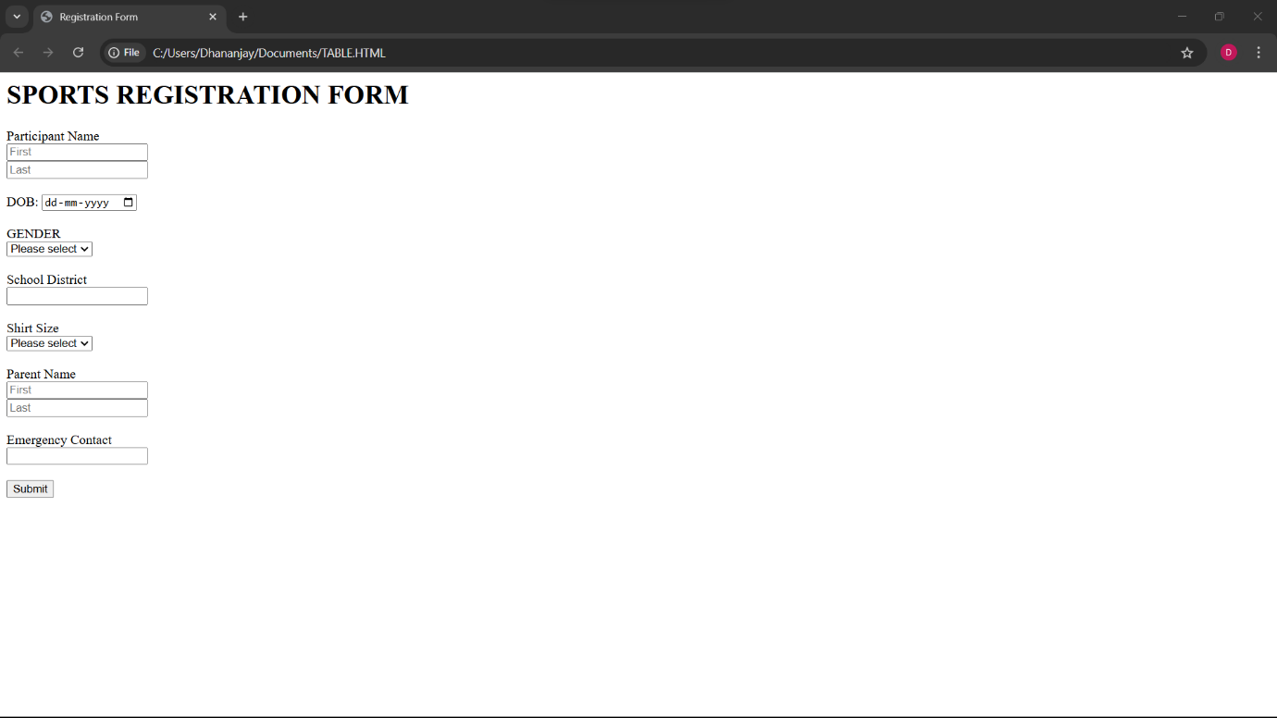

**Q19. Write a HTML code to design a student admission form in html.**

**ANS. <html>**

**<head>**

**<title>Student Admission Form</title>**

**</head>**

**<body>**

**<h1>Student Registration Form</h1>**

**<form action="submit.php" method="post">**

**<label for="student_name">Student Name</label>**

**<input type="text" id="student_name" name="student_name" required><br><br>**

**<label for="date_of_birth">Date of Birth</label>**

**<input type="date" id="date_of_birth" name="date_of_birth" required><br><br>**

**<label**

**for="gender">Gender</label>**

**<input type="radio" id="male" name="gender" value="male">**

**<label for="male">Male</label>**

**<input type="radio" id="female"**

**name="gender" value="female">**

**<label for="female">Female</label><br><br>**

**<label for="address">Address</label><br>**

**<textarea id="address" name="address"**

**rows="5" cols="30" required></textarea><br><br>**

**<label for="phone_number">Phone Number</label>**

**<input type="tel" id="phone_number" name="phone_number" required><br><br>**

**<label for="email">Email</label>**

**<input type="email" id="email" name="email" required><br><br>**

**<label for="cOURSE">COURSE</label>**

**<select id="cOURSE" name="cOURSE" required>**

**<option value="1">BCA</option>**

**<option value="2">LAW</option>**

**<option value="3">B.COM</option>**

**<option value="4">B.TECH</option>**

**<option value="5">BBA</option>**

**</select><br><br>**

**<label for="guardian name">Guardian Name</label>**

**<input type="text" id="guardian name" name="guardian name" required>**

**<label for="guardian contact">Guardian Contact</label>**

**<input type="number" id="guardian contact" name="guardian contact" required><br><br>**

**<label for="10TH MARKSHEET">10TH Marksheet</label>**

**<input type="file"><br><br>**

**<label for="12TH MARKSHEET">12TH Marksheet</label>**

**<input type="file"><br><br>**

**<label for="migration_certificate">Migration Certificate</label>**

**<input type="file"><br><br>**

**<label for="Character_certificate">Character Certificate</label>**

**<input type="file"><br><br>**

**<input type="submit" value="Submit">**

**</form>**

**</body>**

**</html>**

**OUTPUT –**

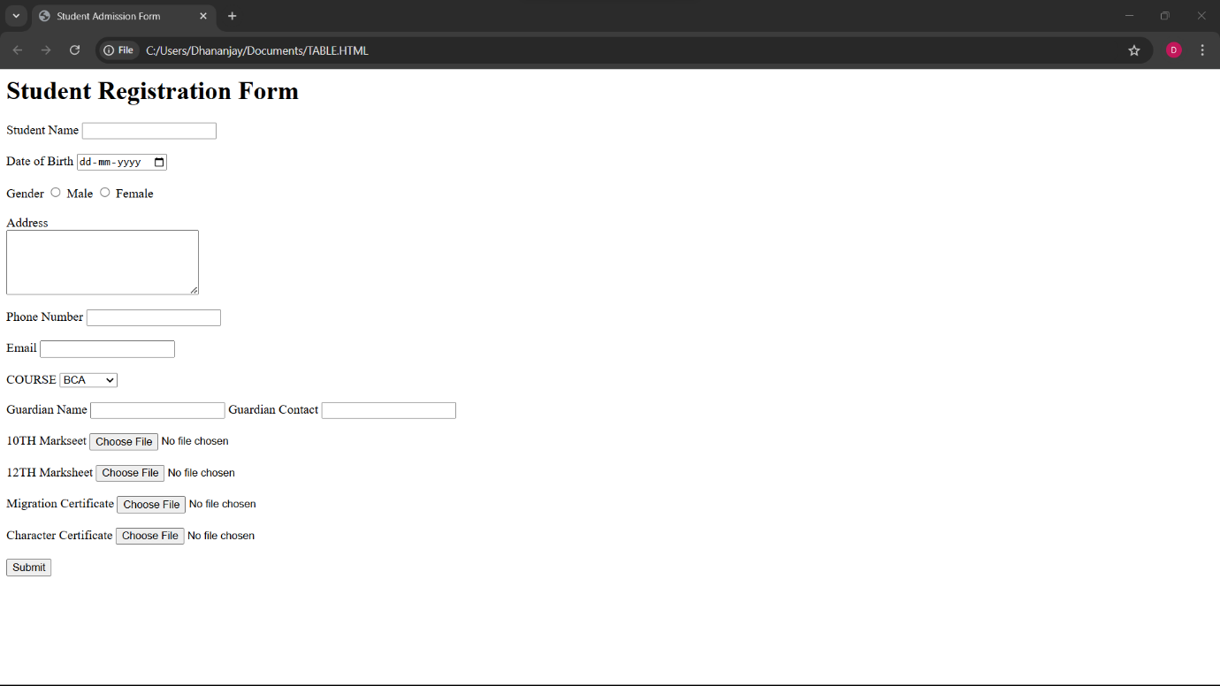

**Q20. Create a home page of your own using any component and style.**

**ANS.**

**<html>**

**<head>**

**<style>**

**H1, h2, h3 {**

**text-align: LEFT;**

**color:orange;**

**}**

**#para1 {**

**text-align: center;**

**color: Yellow;**

**font-size:20;**

**}**

**.center{text-align: center;**

**color: Green;**

**font-size:30;**

**font-family: sans-serif;**

**}**

**</style>**

**</head>**

**<body bgcolor="BLUE">**

**<H1><center>CSS</h1></center>**

**<h2><center> Use to style an HTML document </h2></center>**

**<p id="para1">CSS save alot of work as it can control the layout of multiple web pages all at once </p>**

**<p class="center"> External stylesheet are stored in CSS file</p>**

**<hr>**

**</body>**

**</html>**

**OUTPUT –**

